And here we are again for another productive learning session.
This tutorial will show you how to create your own Enums and Types.

How to create Types

Firstly you have to decide to make it Public or Private.
You can determine this by If you want it available to one section of your project or the entire project, or If your just putting it into a form.

If you are putting it into a form you must use Private otherwise create a Module and make it Public.

Then we need a name for our type. For the demo I will use the name Test

So now we have:

Now any variables we create after this will be included in the Type.
To close off the type we use End Type

Our example looks something like this:

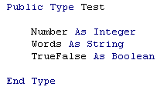

Now we can assign out type to a variable using:

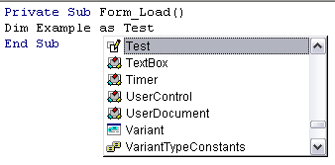

We now can assign values to the variables within the type.
Example: Example:
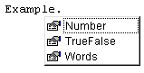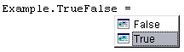

When creating a type you can also include other types as long as they are defined beforehand.

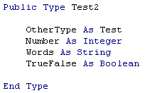

How to Create Enums

Just the same as before you need to determine whether to use Public or Private.
A way of describing Enums is a type containing constants.

Just as we did the type we Need a name for out Enum.
We will call outs ‘Demo’

We then set our Constant names to a value.
Then we close it off using the End Enum Tag.

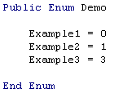

Now what is the point of having an Enum?
Well I will show you. It’s a neat and efficient way of limiting the choice variables.
And also works well in subs and Functions.

Example:
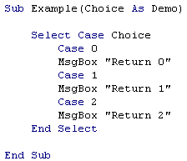

This is what happens when you now call the sub

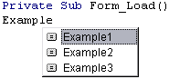

There that concludes this lame tutorial hopefully this was useful to someone.
If you have any comments, tips, questions please don’t hesitate to ask.
Also if you would like me to write a tutorial on a particular topic then give me a yell and I will see what I can do.

Please remember to vote if you like this.

